**Predicting the best place to open a luxury hotel in Brussels, Belgium**

Shalakha Khandelwal

November 30, 2019

1. **Introduction**

My report is for those who are planning to start a new hotel in the city of Brussels. I will provide a suggestion on what would be the best venue to start a new hotel in this densely populated and highly visited city.

Brussels, officially the Brussels-Capital Region, is a region of Belgium comprising 19 municipalities, including the City of Brussels, which is the capital of Belgium. The Brussels-Capital Region is located in the central portion of the country and is a part of both the French Community of Belgium and the Flemish Community, but is separate from the Flemish Region (in which it forms an enclave) and the Walloon Region. Brussels is the most densely populated and the richest region in Belgium in terms of GDP per capita.

Unassuming Brussels is the capital of Belgium, Flanders and Europe. Medieval Grand-Place, is indeed grand, with many 17th-century buildings and daily flower markets. Reopened in 2006, the Atomium, Brussels' Eiffel Tower, provides great views, inside and out. Architecture fans should visit Musee Horta, home of Belgian master architect Victor Horta. St. Gery's clubs and bars are packed year-round. Seafood eateries abound in Ste. Catherine. Walk, rather than get snarled up in traffic, in the narrow streets.

1. **Business Problem**

In my report, I will focus on the issue of where to open a new hotel in a city like Brussels, once one has decided to go ahead. Let’s imagine Marriott Hotels are willing to open a new luxury hotel, the first and foremost important decision will be the location for its new hotel.

1. On what basis can they decide the new hotel's location?
2. While selecting the place there are key points to consider like they need to check where the most well-visited venues of the city are?
3. If in case there are already other luxury hotels which have good ratings, will it be risky to open new one near these hotels?
4. Out of scope for this project: Rent and land values in the neighbourhoods, budget for the interior decoration of the hotel, budget for opening different restaurants in the hotel etc.
5. **Data acquisition and cleaning**

As we are creating a report for those who want to open a new luxury hotel in Brussels.

1. The first requirement is to collect Brussels postal codes data with the name of respective neighbourhoods.
2. The second requirement would be collect data related to latitude and longitude values of the same neighbourhoods.
3. The third requirement would be clean data as required for the analysis and
4. The fourth requirement would be to merge two datasets to be used for exploratory analysis.
   1. **Data acquisition**

There are 19 municipalities in Brussels with different neighbourhoods. We will explore each municipality and their respective neighbourhoods to check which neighbourhood has the most visited venues and would be perfect to open a new hotel. We will extract the data from below Wikipedia page using Beautiful Soup.

[List of municipalities Brussels-Capital Region](https://en.wikipedia.org/wiki/List_of_municipalities_of_the_Brussels-Capital_Region)

We will extract the data related to latitude and longitude values of Neighbourhoods with a csv file (**zipcode-belgium.csv**) saved at local machine and then at the server.

Now once we have the latitude and longitude data, let's use Foursquare Location to get the amount of most visited venues per Neighbourhood, which will give us an idea of where the tourist are moving when visiting the city. This will already show us the best Neighbourhoods to start a luxury hotel. The details can be retrieved using search endpoint. Link to the dataset is:

[Foursquare Developer site](https://developer.foursquare.com/docs/data)

* 1. **Data preparation and cleaning**
     1. **Data cleaning for Neighbourhood data with their postal codes**

Data is extracted from below Wikipedia page using Beautiful Soup.

[List of municipalities Brussels-Capital Region](https://en.wikipedia.org/wiki/List_of_municipalities_of_the_Brussels-Capital_Region)

The required data is in table with table class – ‘wikitable sortable’, so we extract data from this table and transform this data into a new pandas data frame. Data cleaning here will include removing extra columns from the data frame, changing data type of postal codes from string to integer etc.

The final postal code data frame looked as below –

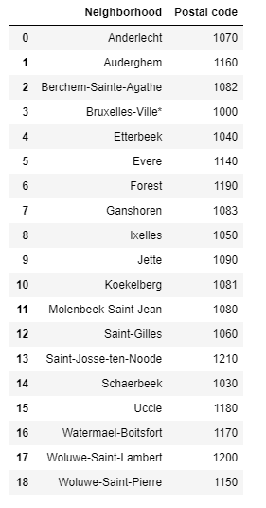

* + 1. **Data cleaning for Neighbourhood data with their latitude and longitude values**

This data was extracted from a csv file named – **zipcode-belgium.csv** located at my local system which has columns – Postal code, Neighbourhood, Latitude, Longitude. This file was then saved to my Watson studio server and data was extracted in my notebook using pd.read_csv function to pandas data frame.

Below is the screenshot of top 5 rows of data in df_data_0 data frame –

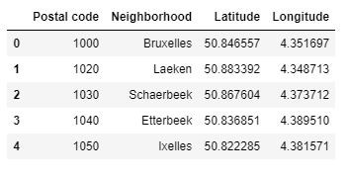

* + 1. **Merging two data frames into a single data frame for further analysis**

The two data frames were merged using pd.merge function and below is the screenshot of top 5 rows of resulting data frame(Brussel_df) –

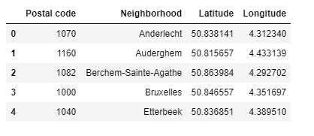

1. **Exploratory Analysis**
   1. **Importing libraries and creating map of Brussels with Neighbourhoods**

After data acquisition and cleaning, I started with exploratory analysis of data. The first step was to import all desired libraries like matplotlib and associated plotting modules, geocoder nominatin to convert an address to latitude and longitude values, K-means for clustering stage and folium(map rendering library).

The second step was to use geocoder to get latitude and longitude values of Brussels and create a map including all the Neighbourhoods of Brussels. Below is the screenshot of map created –

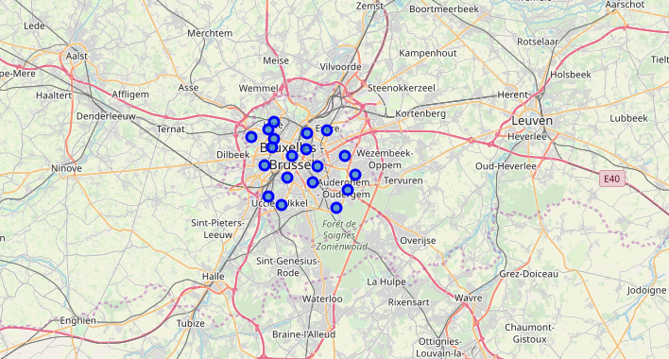

* 1. **Creating a data frame with top 10 venues of each Neighbourhood**

After creation of Brussels map with all the neighbourhoods, I created a data frame with top 10 venues of each neighbourhood. For that, I first created a function to get nearby venues of each

neighbourhood, grouped the data in this data frame based on ‘Neighborhood’ column and using onehot encoding created a new data frame(Brussel_grouped) with frequency of each venue in neighbourhoods.

I then used Brussel_grouped data frame to calculate top 10 venues of each neighbourhood. Below is the screenshot of top 5 rows of the resultant data frame(neighbourhoods_venues_sorted) –

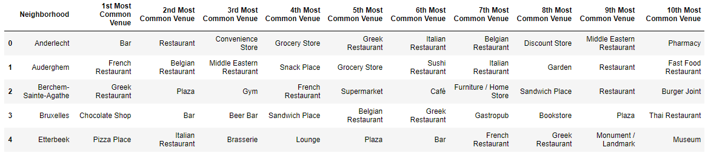

* 1. **Cluster Neighbourhoods - Run k-means to cluster the neighbourhoods into 7 clusters**

After grouping the data based on Neighbourhoods and calculating 10 most common venues of each neighbourhood, I then used K-means clustering to create 7 clusters from Brussel_df data frame and then merge it with neighbourhoods_venues_sorted data frame into a new data frame named Brussel_merged.

Below is the screenshot of top 5 rows of resultant data frame –

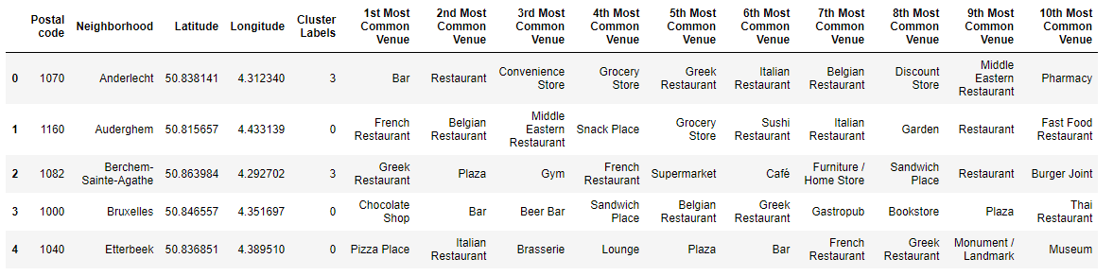

* 1. **Visualizing resulting clusters**

From the resulting data frame – Brussel_merged, I then created a map showing all the clusters created. Below is the attached screenshot of map created –

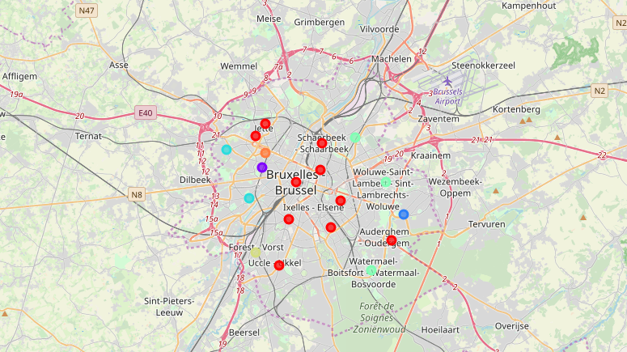

I then visualized each cluster to check which neighbourhood will be well suited to open a new hotel in Brussels. Below is the analysis for different clusters created –

* + 1. **1st Cluster**

The 1st cluster consists of most of the municipalities situated in centre of Brussels consisting of a lot of venues and some of the locations tourists would be interested in visiting.

In this cluster, the neighbourhoods which we would be most interested in are 1000 Brussels, 1040 Etterbeek and 1050 Ixelles. These municipalities are located in the centre of the city and have most common venues like bars, restaurants and chocolate shops located nearby. Many of the touristic attractions like grand place, maneeken pis are located in centre of the city.

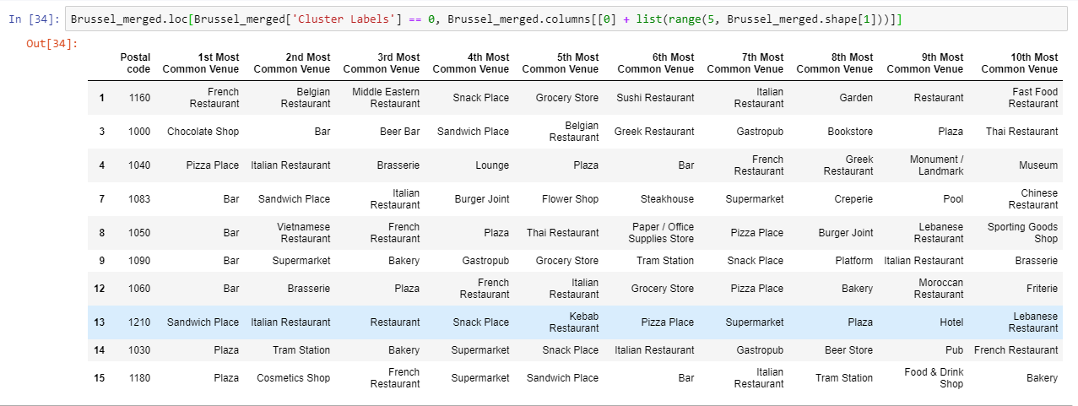

* + 1. **2nd Cluster**

The 2nd cluster consists of only one neighbourhood with most common venues like supermarket, spa and performing arts venue.

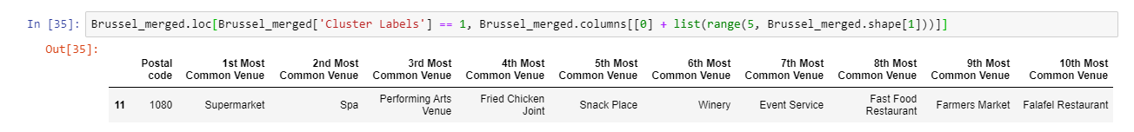

* + 1. **3rd Cluster**

The 3rd cluster as well has one neighbourhood with most common venues like Sports club, hockey field and park.

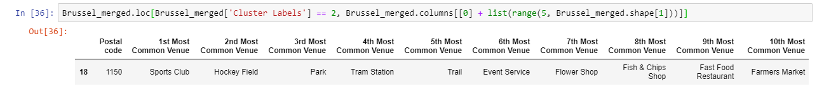

* + 1. **4th Cluster**

This cluster consists of 2 neighbourhoods with most common venues like Bar, plaza, convenience store and gym.

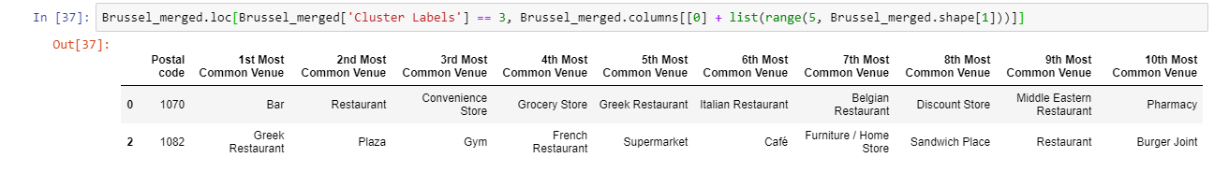

* + 1. **5th Cluster**

5th cluster consists of three neighbourhoods with most common venues like restaurant, park, bakery and pharmacy.

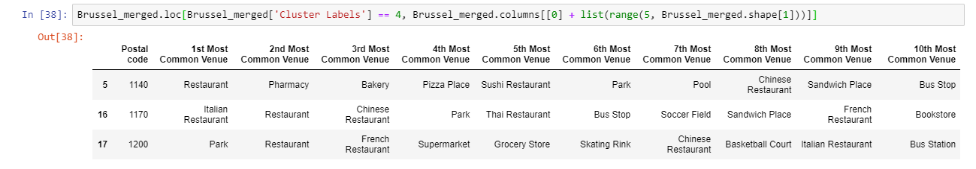

* + 1. **6th Cluster**

6th cluster consists of one neighbourhood with most common venues like supermarket, pharmacy and health food store.

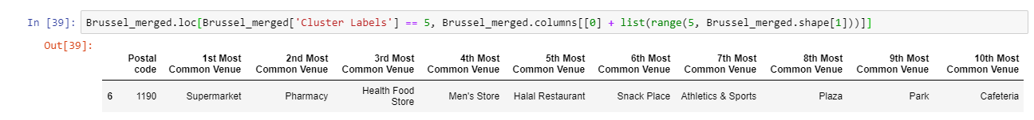

* + 1. **7th Cluster**

7th cluster consists of one neighbourhood with most common venues like gym, hostel and breakfast joint.

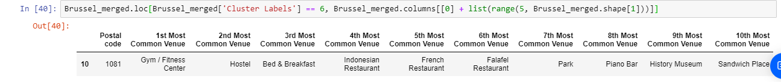

1. **Results**

The following are the highlights of the 7 clusters above:

1. The most common venues are clearly located in 1st Cluster (centre of Brussels), which makes the choice of the final location very easy.
2. As for restaurants, bars, coffee shops and chocolate shops are very popular also in 1st Cluster (centre of Brussels), Especially in 1000 Brussels, 1040 Etterbeek and 1050 Ixelles.
3. Although, the Clusters have variations, a very visible presence is the predominance of chocolate shops, tourists locations and bars and restaurants, so new hotel can be opened in those places.
4. **Discussion and Conclusion**

It is noticeable that 1st Cluster is the most viable clusters to build a new luxury hotel with guarantees. The proximity to a big number of Restaurants (lunch and dinner venues for guests), Coffee shops and other amenities and accessibility to station are also very important points to take into account when making the right choice.

The municipalities like 1000 Brussels, 1040 Etterbeek and 1050 Ixelles, lies in the centre of Brussels and have proximity to all kind of most common venues visited by locals as well as tourists. These neighbourhoods could be the best places to open new luxury hotel in the city.

In conclusion, this project would have had better results if there were more available data in terms of actual land pricing data within the area, public transportation access and allowance of more venues exploration with the Foursquare (limited venues for free calls). However, based on the available data, my advice to Marriott group would be to focus on 1000 Brussels, 1040 Etterbeek and 1050 Ixelles when investing on a new luxury hotel.